For the first time, primary source evidence of Corbett’s exhibitions with both Dave Eiseman and Mike Cleary has been located and revealed herein, clearing up a century’s worth of prior uncertainty and confusion regarding when these bouts actually took place and what happened.
On August 28, 1885, the Olympic Club held another one of its exhibition nights before a crowd of 1,500 to 2,000 spectators. Professional Mike Cleary was the featured guest, and he sparred with two amateurs: Jim Corbett and Dave Eiseman, who later in the evening sparred with each other. Boxing Cleary was significant for Corbett because the 5’8 ½” 175-pound Cleary was well respected and world renowned, considered both powerful and skillful.
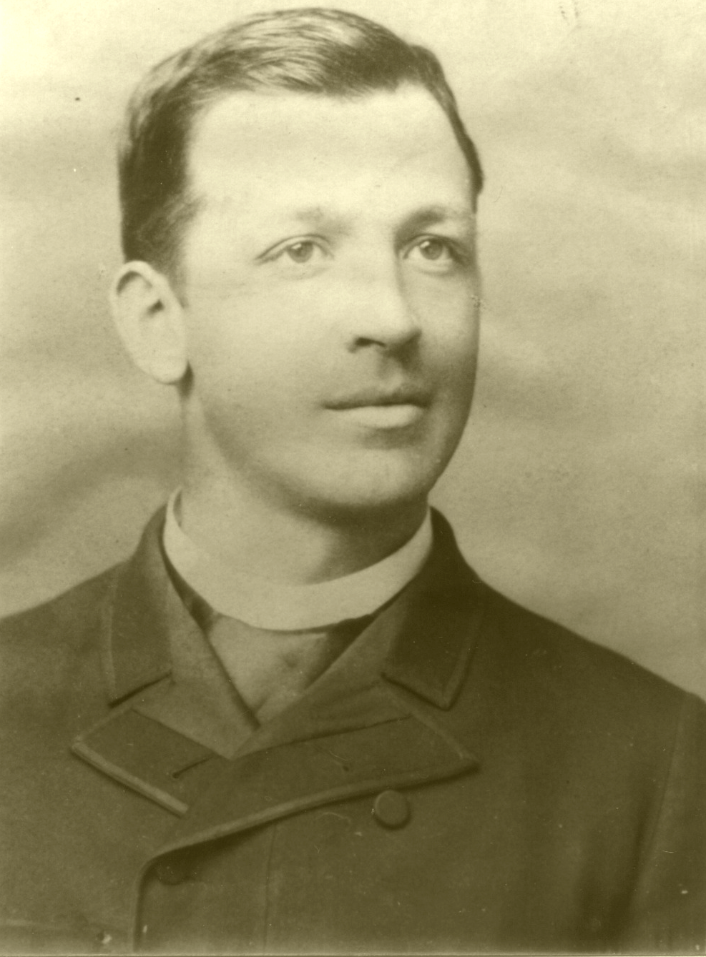
Mike Cleary had fought the who’s who of boxing, having many recorded fights going all the way back to 1875. Amongst his more notable early bouts, he defeated Jimmie Weeden in an 1876 70-round bareknuckle fight that lasted 1 hour and 38 minutes. The powerful Cleary had won quite a few of his numerous fights via early knockout, usually as a result of his famed right hand. He had an 1882 KO3 over
Mike Cleary, 1885 former John L.
Sullivan foe George Rooke. In 1883, Cleary engaged in a 3-round exhibition bout with Sullivan. Mike was reported to have had a 5-round draw with Dominick McCaffrey. In 1883, Cleary was dropped and being pounded on by Charley Mitchell until the police stopped the bout in the 3rd round. In 1884, Cleary fought Jake Kilrain to a 4-round draw and “lost” a 4-round official draw decision to Jack Burke.
In February 1885, Cleary knocked out former Sullivan opponent Captain James Dalton in the 1st round. The police stopped a May 1885 Cleary-Mitchell rematch in the 4th round, with Mitchell being the superior fighter. One report said of Cleary that “[h]e has a right half-arm jolt that is simply terrible.”
According to the local Daily Alta California,

Mike Cleary was the star of the evening, and his appearance with the club members gave many of the onlookers valuable points and hints as to the defects of amateurs generally, which do not become conspicuous until shown off by comparison with a graceful professional.

Cleary boxed 2 rounds with Corbett, who was called the “coming heavyweight of the Club.”

Corbett and Cleary opened, and gave a very clever exhibition. Corbett’s reach and strength were tremendous, but not equal to Cleary’s science and quickness, and the latter was easily able to secure the best of it, especially as Corbett did all the leading. Mike was very gentlemanly, however, and did not attempt to make a show of his opponent, who has only been taking lessons something over three months. In the second round Corbett wisely let Mike do the leading, and contented himself with solid returns without making much of an attempt to guard.

This account, by saying that Corbett had only been taking lessons for “something over three months,” supports the position that Corbett began taking lessons from Walter Watson in around May 1885. It also once again indicates that Corbett was a heavyweight, even at that point. Also, although well thought of, the much less experienced Corbett was not seen as being quite on Cleary’s level. Other local accounts agreed.
According to Corbett, after they boxed, Cleary told him that he was a comer and would be a great boxer one day, that Corbett got away from his right better than anyone he had ever fought. There is later evidence that Cleary was in fact quite high in his regard for Corbett.
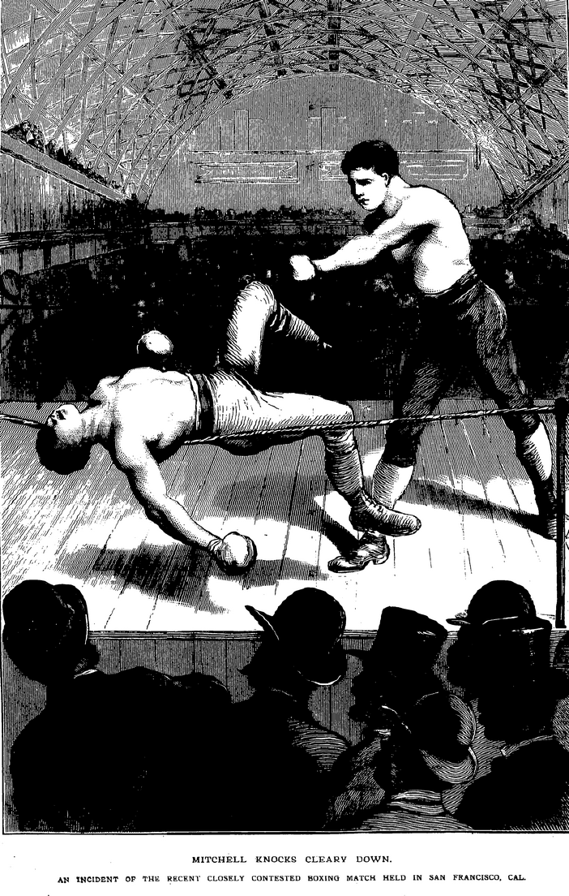
Mitchell defeats Cleary in San Francisco, 1885
After Cleary and Corbett sparred, Tom McCord and Jimmy Smith boxed 2 rounds. Cleary then sparred 2 rounds with Dave Eiseman. Eiseman was vigorous with his onslaughts, but Cleary eventually took control of matters. Eiseman gave a very creditable showing in both rounds and was applauded. McCord and Smith then boxed 2 more rounds while Eiseman rested.
The final bout of the evening was between Corbett and Eiseman.

Corbett was considerably the larger, but Eiseman was confident that his experience and science would carry him through, and he began fighting. The adherents of both were doubtful of the result, but it was not long in abeyance, for a most complete transformation took place. Corbett, who made a comparatively poor showing with Cleary, went at once to the front, and Eiseman, who had done very well, retrograded until he was but a child in the heavyweight’s hands. The hitting was hard and rapid, and Corbett punched the unfortunate all over the ring, fighting him to a standstill just as time was called at the end of two minutes. The second round opened vigorously, but Eiseman was too distressed at the end of a few seconds to continue it, and appealed to the referee to know whether the contest was a setto or a fight to a finish. The official admonished Corbett, but a heavy left-hander from Eiseman set the ball rolling again, and before two minutes was up Eiseman quit, partly through the intervention of friends and partly through desire.

The Chronicle also confirmed that Corbett and Cleary sparred, though without providing details, and gave its description of the Corbett vs. “Eisman” exhibition.

The final bout was between the two club men, Eisman and Corbett. The latter was fresh and outweighed his opponent, who had not wholly recovered the wind which Cleary knocked out of him. In the first round there was some hard hitting, in which Corbett got the better of it. In the second round Corbett went in for a knock-out, and Eisman’s condition by that time was so much impaired that he was quickly fought to a standstill and a knock-out would have followed, had not Professor Watson, the boxing teacher, stopped the contest.

The San Francisco Call confirmed that Cleary boxed 2 rounds each with Corbett and Eisman, “in which the superiority of professional over amateur boxing was only too apparent.” It said that the event of the evening was the wind-up between Corbett and Eisman, “each claiming superiority as a boxer and representing different factions in the club.”

Eisman appeared to poor advantage from the first, being no match for his antagonist, who is a much heavier man than he and consequently forced him around the circle, tapping him hard or light as he felt inclined and showing a decided preference for fairly hard amateur hitting from the shoulder. In the second round the referee reminded Corbett that the boxing was only for fun, while Eisman showed an inclination to quit. Corbett in the middle of the round good naturedly poked his glove under the nose of his mortified antagonist several times and Eisman, concluding that he had had enough, retired from the circle amid the whoops and yells of Corbett’s delighted friends. Neither men displayed any science in the encounter and Corbett’s victory was purely the result of superior weight, strength and good nature.

Another less detailed local source, The San Francisco Evening Post, said that Cleary showed that he knew much more about boxing than Eisman and Corbett, and that the set-to between Corbett and Eisman was a slugging match until the referee interfered. “The club experts say that Corbett was all over Eisman.”
These accounts alter the previous historic understanding of Corbett and Eiseman’s meeting. Clearly, this was part of an exhibition show in which both had previously boxed Cleary, Corbett was a heavyweight and was much larger than Eiseman (who one month earlier had been listed at 137 pounds), the rounds were only two minutes long, and in the 2nd round, Eiseman either voluntarily retired or it was stopped by Professor Watson, not wanting to see him absorb further punishment and be completely knocked out. This was not Jim’s first bout at the Olympic, nor was it a bout for the club middleweight championship as some have reported. The press generally referred to Corbett as a heavyweight and Eiseman as a middleweight.
An 1889 account of his career said that the Eiseman bout took place three months after Corbett entered the Olympic Club, after his bout with Fulda. If true, it would put Corbett’s entry into the Olympic in 1885. The Welch bout was not mentioned by this source.
The day after the Corbett-Cleary/Eisman exhibition, on August 29, 1885 in Cincinnati, Ohio, heavyweight champion John L. Sullivan won a 7-round decision over Dominick McCaffrey, dropping Dominick several times throughout. Later that year it was said that Sullivan had earned at least $157,000 in his career, but his spendthrift attitude and tours of bar rooms calling for wine had left him $16,000 in debt.

Boxrec.com; Daily Alta California, March 2, April 27, 1885. Cleary would much later help spar with and prepare John L. Sullivan for his 1889 bout with Jake Kilrain.
Daily Alta California, August 29, 1885. Corbett and others have incorrectly claimed that these exhibitions took place in 1884, and on different dates.
Corbett at 28.
Daily Alta California, August 29, 1885.
San Francisco Chronicle, August 29, 1885.
San Francisco Evening Post, August 29, 1885.
Daily Alta California, July 25, 1885; San Francisco Chronicle, July 25, 1885; San Francisco Call, August 29, 1885.
San Francisco Evening Post, May 30, 1889.
Daily Alta California, October 5, 1885.

